**SimpleDSFviewer: a tool to analyse and view differential scanning fluorimetry data for characterising protein thermal stability and interactions**

**Supplementary:**

**1 File Table:**

**(1) Code files (**Folder: SimpleDSFviewer MATLAB code**):**

**SimpleDSFviewer.m (SimpleDSFviewer.fig)** is the main script, which displays the user interface and contains the buttons and parameter inputs.

**Normalisemc.m** is connected to the user interface script to normalise the melting curves by using the parameters loaded into the user interface.

**Smomcurve.m** is used to smooth the melting curves if it required.

**Peaknumber.m** is used to screen the melting curves, which automatically classifies the curves. The different curves shown in Fig. 4 A can be recognised automatically, and the parameters for classifying the curves can be changed manually.

**mapTm.m** is to generate the preview map (Fig. 4 C) and 3 D bar plot graph (Fig. 4 D).

**(2) Runtime app files (**Folders:SimpleDSFviewer Mac/Win32/Win64 runtime**):**

**SimpleDSFviewer.exe** is the software package for running the program. Choose the appropriate version, depending on the computer (Windows 32 or Windows 64 or Mac), and double click this file to run the program. The required Matlab Runtime should be installed before running this software.

**readme.txt** contains the details which introduce the requirement of installation of MATLAB runtime.

**Other files** are icon pictures and supporting files.

**(3) Example data (**‘example raw.xlsx’ and ‘example sorted.xlsx’**).**

**2 User instructions:**

1. **Start the program:** Open SimpleDSFviewer.m in MATLAB R2015a (containing ‘Signal Processing Toolbox’, ‘Statistics and Machine Learning Toolbox’ and ‘Curve Fitting Toolbox’) and run the script. Alternatively, install the desired MATLAB Runtime 2015 (download from webpage: <http://uk.mathworks.com/products/compiler/mcr/>) and open the compiled app (SimpleDSFviewer), if MATLAB software is not installed. The interface (Fig. S1) will be loaded and ready to use. A Windows computer is preferred, since the analysed data cannot be written into an Excel file for ‘Save Data’ function on a Mac computer.

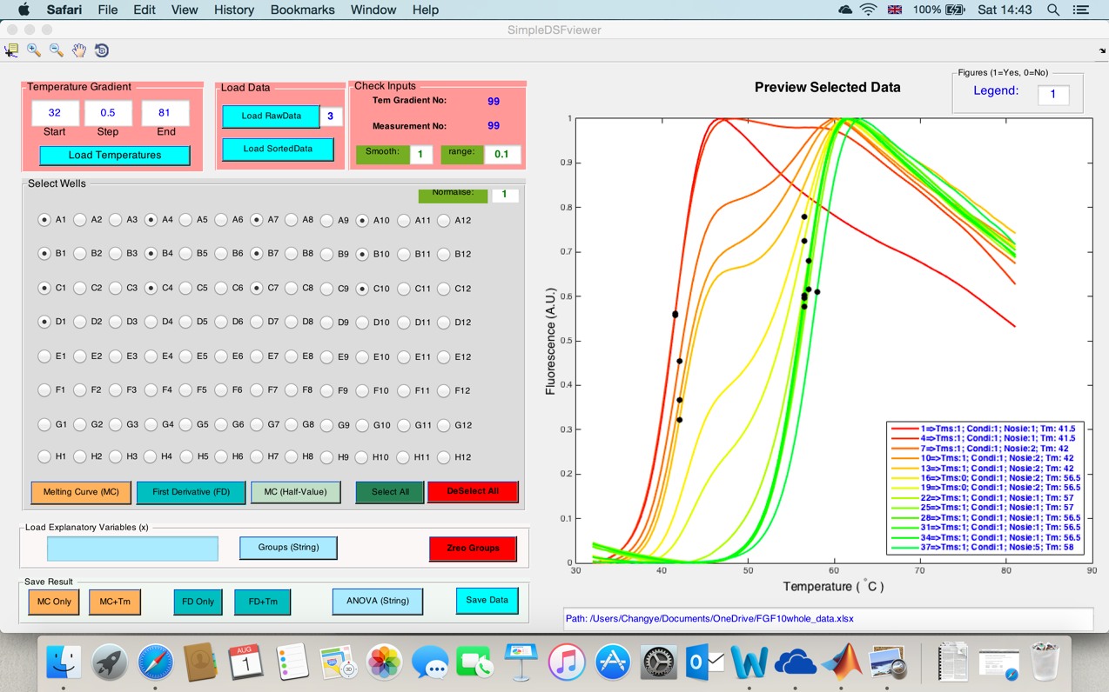

**Figure S1 User interface of SimpleDSFviewer.** This figure shows the user interface of SimpleDSFviewer, in which the user can analyse and view the collected DSF data. The top-left three panels are used to load the parameters and collected DSF data. The 96 well radio buttons and the data view buttons are distributed on the bottom left. The right side contains a graphical view box for displaying the selected data and the path of input data in a text box.

1. **Load parameters:** The temperatures, including start temperature, temperature step and end temperature are required, if a raw data file (Fig. S2 A) is to be loaded. In the software, ‘1’ signifies Yes and 0 signifies No for ‘*Smooth*’, ‘Normalise’ and ‘Legend’ parameters. The *Smooth* and *Normalise* parameters should be kept as ‘1’ as the data are loaded, but the range (*Smooth Range*) can be changed to be increased or decreased. The ‘*Normalise*’ and ‘*Smooth*’ functions can be turned off when the original melting curves are desired.

The default values are loaded automatically and are generally ideal for analysis.

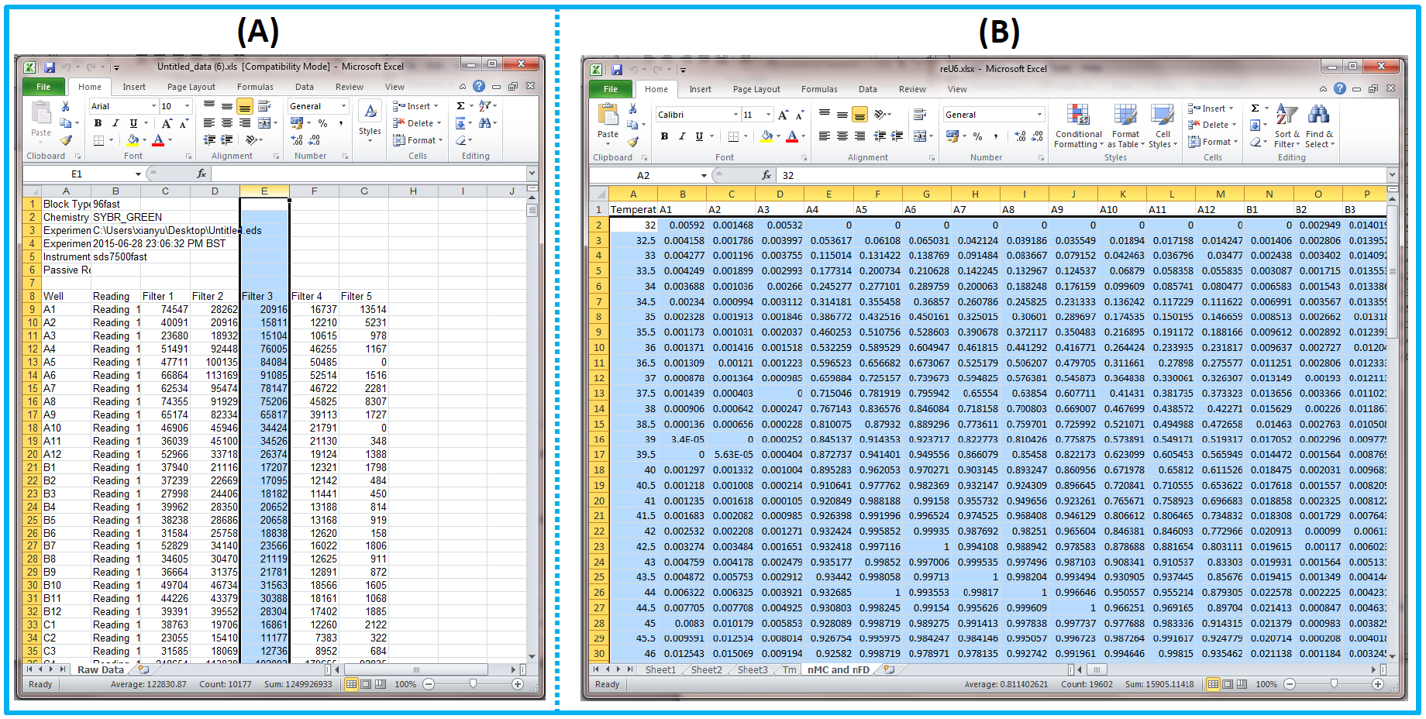

**Figure S2 Templates of input data for SimpleDSFviewer.** Two formats of input data can be loaded into the program. (A): Raw data contains all the fluorescence reading from wells 1 to 96 and from the lowest temperature to the highest temperature in one column. The number of desired column needs to be specified. (B): Sorted data contains the melting temperature in the first column and the 96 wells’ fluorescence in 96 columns.

1. **Load experimental result:** Two formats of data can be loaded, as shown in Fig. S2. The first format is the raw data, which contains all the data in a single column and the column that contains the desired data should be specified (Text box next to ‘*Load RawData’* pushing button, Fig. S1). Column 3 was selected in the example (Figs. S1 and S2 A). The second format is sorted data (Fig. S2 B), which contains 96 columns corresponding to 96 wells and fluorescence intensities of each temperature in each row. The loading data should be stored in the first sheet of the Excel file.
2. **Functions:** Multiple wells can be selected by clicking the corresponding radio buttons for data view. The melting curves and first derivative curves can be previewed in the graph box (Fig. S1) by pushing the buttons (containing MC or FD) in the *Select Wells* panel or be viewed and saved by pushing the buttons in the *Save Result* panel. ‘+Tm’ means the melting temperature is marked on the melting curve. MC (Half-Value) shows the melting curves with half denaturation point (main paper 3.3). The legend can be added by changing the legend parameter to ‘1’.

*Different samples can be compared by ANOVA:* Repeating samples are selected by clicking the radio buttons and a name should be input into the text box in the ‘*Load Explanatory Values (X)*’ panel. Then, the sample is added by pushing the ‘*Group (String)*’ button. The selected wells should be deselected and more samples can be added in the same way. The ANOVA (string) button will give the statistical analysis and a box-plot graph for the samples under comparison.

1. **Save function:** The sorted (Sheet1) and normalised melting curves (Sheet: nMC and nFD) and the first derivative curves and the melting temperatures (Sheet: Tm) calculated by the three different methods (Fig. 1) may be saved as an Excel file by pushing ‘*Save Data’* button.
2. **Errors:** When the data are input into the program, a running status bar will be displayed on the screen and it will be turned off after the auto-analysis. However, if the running cannot be completed (bar status), the input data should be checked. For example, if the gradient numbers of temperature are longer than the fluorescence measuring numbers for each well, an error will be generated and running will not complete. Missing values in the loaded data also cause the same problem.
3. **Example data:** Protein and the heparin (Hep) ligand concentrations are listed in the following table. Every three consecutive wells contain three same samples to ensure the experimental results.

|  |  |  |  |
| --- | --- | --- | --- |
| FGF10  PBS | FGF10  Hep 0.2 µM | FGF10  Hep 0.3 µM | FGF10  Hep 0.4 µM |
| FGF10  Hep 0.5 µM | FGF10  Hep 0.625 µM | FGF10  Hep 0.75 µM | FGF10  Hep 0.875 µM |
| FGF10  Hep 1 µM | FGF10  Hep 1.25 µM | FGF10  Hep 2.5 µM | FGF10  Hep 5 µM |
| FGF10  Hep 50 µM | FGF10  Hep 500 µM | FGF10  PBS | FGF10  Hep 0.2 µM |
| FGF10  Hep 0.4 µM | FGF10  Hep 0.5 µM | FGF10  Hep 0.625 µM | FGF10  Hep 0.75 µM |
| FGF10  Hep 0.875 µM | FGF10  Hep 1 µM | FGF10  Hep 1.25 µM | FGF10  Hep 2.5 µM |
| FGF10  Hep 5 µM | FGF10  Hep 50 µM | FGF10  Hep 500 µM | FGF10  8 M urea |
| FGF10  PBS | FGF10  Hep 50 µM | FGF10  0.5% Tween-20 (v/v)  PBS | FGF10  0.5% Tween-20 (v/v)  Hep 50 µM |